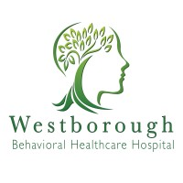

Special Needs Unit

Parent Handbook

Table of Contents

Welcome …………………………………………………………………….………………………..2
Program Philosophy ……………………………………………………...…….…….………….2
Program Model and Therapeutic Interventions………………….…….……..……..3
- Psychiatry
- Medication
- Occupational Therapy
- Functional Behavior Assessment & Data Collection
- Skill Development

Zones of Regulation Framework ………………….…….…………………………….5
Social Skills Development ………………….……………………………….……………..6
Sample Daily Schedule ………………….…….……………………………………..…..….6
Family Services and Caregiver Training ………...…………….……………..…….7
Educational Services ………………….………………………………………..…….…...….7
Visitation and Guidelines …………………..………………………….….………..………8
Discharge Planning ……………………………………………….……….…….….………….9
Food Services ………………….………………………………………………..….…….……….9
Helpful Caregiver Tips ………………………………………….……….…….…….……….9
Patient Rights ………………….………………………………………………..….……….…….10
Contact Information ………………………………………………..…….…….……….…….11

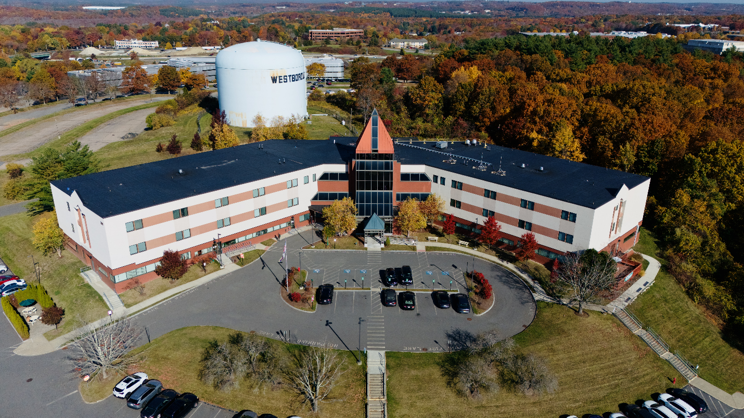

Welcome!
Welcome to the Special Needs Unit (SNU) at Westborough Behavioral Healthcare Hospital (WBHH). Our SNU provides specialized care for children and adolescents, ages 5–17, with autism who are experiencing acute behavioral challenges. We utilize evidence-based treatments tailored to each child's unique needs.
Our primary goal is to stabilize behaviors and equip each patient with the skills necessary for a safe and successful transition to the next stage of their care and support.

Program Philosophy
The Special Needs Unit is built on a philosophy of family-centered care, recognizing parents and guardians as essential treatment team members. We are committed to providing a safe, respectful environment rooted in Applied Behavior Analysis (ABA) principles and a trauma-informed approach.
Our programming is designed to meet the unique needs of each child, focusing on fostering growth, stability, and resilience. To provide the best support for your child, we take a multidisciplinary team approach, integrating the expertise of psychiatrists, registered nurses, clinicians, occupational therapists, Board-Certified Behavior Analysts
(BCBAs), Registered Behavior Technicians (RBTs), and discharge planners. Together, we strive to deliver comprehensive and compassionate care for your child and your family.

Program Model and Therapeutic Interventions

Psychiatry
When your child is admitted to the Special Needs Unit (SNU), a comprehensive psychiatric evaluation will be conducted within 24 hours. The SNU psychiatrist will reach out to gather detailed medical information, discuss medication options, and collaborate with you on treatment planning.
Your child’s care will be overseen by a board-certified psychiatrist with specialized training in child, adolescent, and family psychiatry, in addition to their expertise in general psychiatry. They recognize that every child is unique and at their own developmental stage, ensuring that all interventions are thoughtful, individualized, and developmentally appropriate.
Medications
Medications will not be initiated or adjusted without the consent of a parent or guardian. However, in emergency situations, one-time-use medications may be administered. These medications are reserved for instances where a child’s behavior poses a significant risk of harm to themselves or others and when de-escalation techniques and other interventions have proven ineffective.
Parents or guardians will be promptly notified if such an emergency medication is used.

Restraint and Seclusion Philosophy

Westborough Behavioral Healthcare Hospital is committed to providing a safe, therapeutic, and trauma-informed environment where every patient is treated with dignity, respect, and compassion. We believe restraint and seclusion are emergency interventions of absolute last resort and are used only when necessary to protect the immediate safety of patients or others. Our teams are dedicated to preventing the need for these interventions through individualized care, therapeutic engagement, and evidence-based de-escalation strategies whenever possible. We actively partner with patients and their families when appropriate to support recovery, promote healing, and create the safest environment possible for patients, visitors, and staff.

Occupational Therapy
An Occupational Therapist (OT) evaluates your child’s self-care skills and independence. Certified Occupational Therapy Assistants (COTAs) provide support to enhance these skills based on individual needs and recommendations.

Functional Behavior Assessment & Data Collection
At the start of services, a Board-Certified Behavior Analyst (BCBA) conducts a Functional Behavior Assessment (FBA) to determine the underlying purpose of
challenging behaviors. This assessment informs the creation of a behavior plan with targeted interventions designed to reduce these behaviors effectively.

The BCBA collaborates with staff to implement the behavior plan, ensuring consistency and alignment with the child’s needs. Registered Behavior Technicians (RBTs) support this process through ongoing data collection and weekly graphing, allowing for measurable progress tracking and adjustments as needed.

Skill Development
- Self-Care Skills
An occupational therapy consultation will be conducted by an Occupational Therapist (OT) to assess your child’s level of independence with self-care skills and sensory needs if related to the reason for their admission. Based on the consultation recommendations, unit staff will work to support your child with these daily tasks.
- Self-care (e.g., hygiene, dressing)
- Communication (e.g., requesting needs)
- Self-regulation strategies
Additionally, the Board-Certified Behavior Analyst (BCBA) may provide consultation if challenging behaviors impact your child’s ability to complete self-care activities successfully.
- Self-Regulation Skills
Self-regulation skills help children manage their emotions and behaviors when faced with challenging situations. These skills enable children to:
- Calm themselves when upset
- Adapt to changes in their environment or expectations
- Handle frustration without outbursts
Therapeutic groups on the unit focus on teaching and reinforcing self-regulation skills. Throughout the day, staff prompt children to practice these skills in real-time situations. A Comfort Room is also available for children when they feel overwhelmed, providing a safe and calming space to apply these strategies.

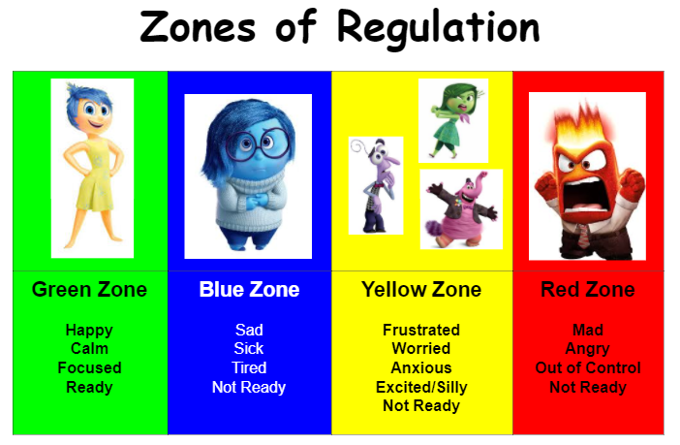

Zones of Regulation Framework
The Special Needs Unit uses the Zones of Regulation Framework to assess and teach self-regulation skills. This framework is a structured, cognitive-behavioral approach that categorizes feelings and states of alertness into four color-coded zones, making emotions easier for children to identify and manage.
The Zones framework provides practical strategies to help children:
- Increase awareness of their emotions and impulses.
- Develop independence in managing sensory needs.
- Improve their ability to handle conflicts constructively.
The Zones of Regulation uses engaging visuals to teach children how to:
- Recognize their feelings and levels of alertness.
- Understand how their behavior affects others.
- Use tools and strategies to manage emotions and maintain self-regulation.

Social Skills Development
Social skills are addressed by a group of peers at scheduled times throughout the day. Each group will have a different topic according to the schedule. Group sessions, led by clinical staff, focus on:
- Role-playing and feedback
- Building a “self-regulation toolbox”
- Developing problem-solving and social awareness
These skills are practiced throughout the day to ensure real-world application.
Sample Daily Schedule
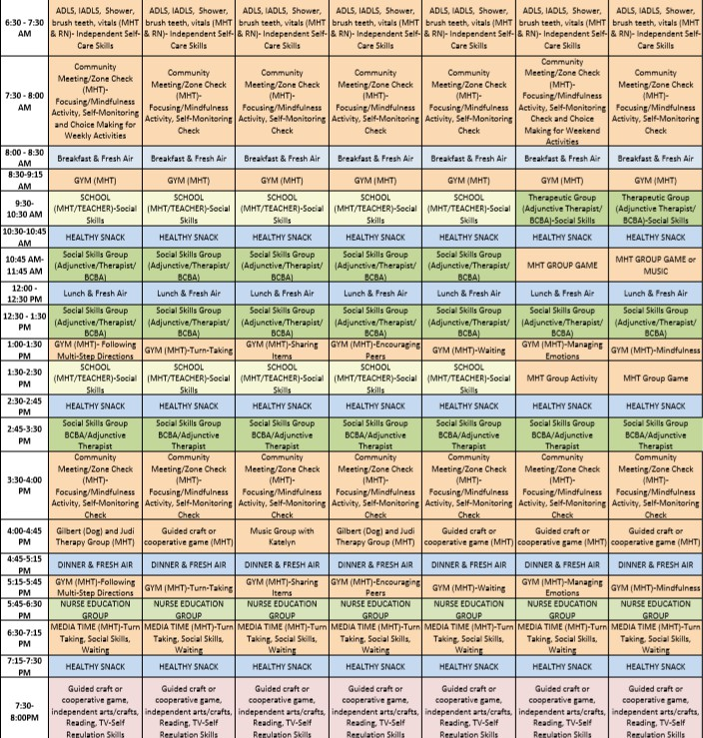
Below is a sample of your child’s daily schedule. This may change based on program needs. Schedules may include activities like yoga and music therapy. Social skills groups and therapeutic interventions are integrated into daily routines.



Family Services and Caregiver Training
Caregiver Training educates parents and/or guardians about the treatment tools implemented during a patient's stay at the hospital. The BCBA also provides education regarding effective behavior strategies across settings, including at home.
Techniques for replacing behaviors and information regarding behavior plans will also be addressed.

Educational Services
Educational services are vital in supporting a child’s reintegration into their external environment. The Special Needs Unit (SNU) provides developmentally appropriate educational programming delivered by a qualified education provider.
Additionally, our team collaborates with your child’s school to ensure a smooth and successful transition to their educational setting upon discharge.

Visitation and Guidelines
Visitors may begin checking in for patient visits 30 minutes before visitation time.
- Special Needs Unit patient visitation times:
- Tuesdays/Thursdays - Afternoon Visits:
Check-In: 1:30 PM
Visit: 2:00 – 3:00 PM
- Mondays/Wednesdays/Fridays - Evening Visits:
Check-In: 6:00 PM
Visit: 6:30 - 7:30 PM
- Weekends & Holidays:
Check-In: 1:30 PM
Visit: 2:00 – 3:00 PM
Visitation can also be arranged with your child’s BCBA Monday – Friday for Caregiver Training during normal business hours.
If these times are inconvenient, please contact the patient's clinician to explore alternative arrangements.

Guidelines
- All visitors must check in with the receptionist in the main lobby, sign in on the register, and obtain a visitor badge. Visitors must also sign out upon leaving.
- Visitors must be 18 years or older. Children cannot be left unattended in the lobby.
- Personal belongings, such as coats, purses, keys, and bags, are prohibited in the visitation area. Cell phones and cameras are prohibited to protect patient confidentiality.
- Visitors can leave belongings in their cars or secure them in complimentary lockers in the hospital lobby.
- For safety, all visitors will be scanned with an electronic device before entering the visitation area to prevent the exchange of contraband.
- Contraband includes items such as weapons, sharp objects, alcohol, illicit drugs, and medications. A complete list of contraband is available upon request at the reception desk.
- Due to space limitations, only two (2) visitors are allowed per visitation session. If more than two visitors arrive, accommodations will be made to ensure everyone can visit while adhering to this limit.
- Any belongings or packages for patients must be left with the receptionist and checked by staff before being given to the patient.
- WBHH maintains a drug- and alcohol-free environment. Visitors appearing under the influence of drugs or alcohol will be asked to leave the property.
- All visitors are expected to respect program rules and the patient’s privacy. Failure to do so may result in being asked to leave.

Discharge Planning
Preparing children to return to their lives outside the hospital is a primary focus and discharge planning begins at admission. Our highly trained clinical team works closely with specialized community providers to create individualized plans that ensure safety and continued progress, to meet the needs of the child and their family.

Food Services
Your child will be provided with snacks and balanced meals, offering a variety of options and choices. Menu planning is overseen by a dietitian to ensure nutritional quality.
A dietary consultation can be arranged at your request or upon recommendation by a member of the treatment team. Special dietary needs or medical considerations will be accommodated through menu modifications as necessary.


Helpful Caregiver Tips
To ensure your child’s comfort and safety during their stay, please keep the following in mind:
Clothing:
- Provide 3 days’ worth of clothing in a disposable brown bag.
- Avoid items with belts, drawstrings, or laces.
- Label clothing with your child’s name or initials.
Comfort Items:
- You may bring one blanket and one stuffed animal for your child.
Food and Electronics:
- Outside food is not permitted.
- Electronics, including cell phones and tablets, are not allowed except for prescribed communication devices.
  - NOTE: We recognize the importance of communicating with your child in the modality that best meets their needs. If your child requires a communication device, we strongly recommend ensuring that the device includes a practice plan and a protective case to prevent damage.

Patient Rights
Westborough Behavioral Healthcare Hospital adheres to the Department of Mental Health’s Six Fundamental Patient Rights:
- A humane psychological and physical environment that supports patient well-being.
- The right to receive visitors daily and privately, as is reasonable and safe.
- The right to receive or refuse visits and calls from your attorney, legal advocate, physician, social worker, psychologist, or clergy.
- The right to send and receive unopened, uncensored mail.
- The right to reasonable access to a phone to make and receive confidential calls.
- The right to daily access to outdoor spaces, as is safe and appropriate.

Contact Information
Westborough Behavioral Healthcare Hospital
300 Friberg Parkway, Westborough, MA 01581
For additional questions or support, please contact us:

- Reception Main Line ……………………………………………….…………………… 508-329-6300

- Child Unit Front Desk ……………………..…………….…………….………………. 508-329-6064

