
Child Unit
Parent Handbook



Table of Contents

Welcome ……………………………………………………….…………….………..…….……..2
Program Philosophy ………………………………………………………….….…………….2
Program Model and Therapeutic Interventions……………….….…………….…2
- Psychiatry
- Emergency Situations and De-Escalation Techniques
- Clinical Staff & Occupational Therapy
- Nursing
- Self-Regulation Skills
- Zones of Regulation Framework
- Social Skills
Sample Daily Schedule ………………………………..…………….……………….…,….…6
Family Services…………………………………………..…………….………………,………….7
Educational Services ……………………………………………………….……,……………..7
Discharge Planning ………………………………………………………….……,……………..7
Visitation…………………………………………………………………………………,……….…..8
Food Services ………………………………………………………………………,……..……….9
Helpful Caregiver Tips ………………………………………………..……………………..…9
Patient Rights ………………………………………………………………..…………………….10
Contact Information …………………………………………….……………..…...………….10

"There is no health without mental health. Supporting a child’s emotional well-being is as essential as nurturing their physical health."
— Adapted from the World Health Organization

Welcome to Westborough Behavioral Healthcare Hospital’s (WBHH) Child Unit.
Our Child Unit is designed to provide specialized care for children aged 5 to 12 in a supportive and therapeutic environment. We address safety-interfering behaviors through evidence-based treatments tailored to each child’s unique needs.
Our primary goal is stabilizing these behaviors and successfully enabling your child to transition to a less restrictive setting.

Program Philosophy
At WBHH, we take a patient- and family-centered approach to care. You and your child are essential partners in developing a personalized treatment plan alongside our treatment team. Our programming is designed to meet the unique needs of each child, with a focus on fostering growth and stability.
We approach care through a trauma-informed lens, recognizing that patients who require hospitalization may have experienced traumatic events. Additionally, we understand that being away from home can be challenging for both the child and their family. Our priority is to provide a safe and nurturing environment that supports and empowers your child during their stay.
To best meet your child’s needs, we use a multidisciplinary team approach that integrates the expertise of nursing staff, psychiatrists, clinicians, clinical case managers, occupational therapists, and discharge planners. Together, we strive to ensure comprehensive, compassionate care for your child and your family.

Program Model and Therapeutic Interventions

Psychiatry
When your child is admitted, they will receive a psychiatric evaluation within 24 hours. This evaluation will be conducted by the Child Attending Psychiatrist (Monday through Friday) or the On-Call Psychiatrist (Saturday and Sunday). The attending psychiatrist will also reach out to you to gather a detailed history and discuss treatment options.
Your child’s Board-Certified Psychiatrist has specialized training in general psychiatry as well as child, adolescent, and family psychiatry. With an understanding that every child is unique and at a specific stage of development, the psychiatrist will use developmentally appropriate interventions tailored to your child’s needs.
Most patients in the WBHH Child Unit take psychiatric medications as part of their treatment. No medication will be started or adjusted without the consent of a parent or guardian. In rare circumstances, medications for one-time use may be administered in emergencies to ensure the safety of your child and others on the unit. If this occurs, you will be notified immediately.

Emergency Situations and De-Escalation Techniques
Emergency medications may be used only in situations where a child exhibits significant self-injuring behaviors, such as head-banging, using objects to self-harm, or demonstrating aggression (e.g., hitting or punching). Our staff are trained in de-escalation protocols to make every attempt to intervene with the least restrictive means. We work with each child to determine effective de-escalation skills unique to them.

De-Escalation Techniques
Staff will first attempt to calm your child using non-invasive interventions, such as:
- Offering an activity or walk
- Providing a snack or drink of water
- Engaging in music or deep breathing exercises
We encourage you to share what strategies work best for your child. Your insights are invaluable in creating a supportive and individualized plan.
The philosophy of WBHH’s Child Psychiatrists is to prioritize the lowest effective dose of medication, ensuring your child receives the support they need while minimizing side effects. This approach aims to optimize your child’s functioning and reduce the likelihood of relapses.

Restraint and Seclusion Philosophy

Westborough Behavioral Healthcare Hospital is committed to providing a safe, therapeutic, and trauma-informed environment where every patient is treated with dignity, respect, and compassion. We believe restraint and seclusion are emergency interventions of absolute last resort and are used only when necessary to protect the immediate safety of patients or others. Our teams are dedicated to preventing the need for these interventions through individualized care, therapeutic engagement, and evidence-based de-escalation strategies whenever possible. We actively partner with patients and their families when appropriate to support recovery, promote healing, and create the safest environment possible for patients, visitors, and staff.

Clinical Staff & Occupational Therapy
Our clinicians, clinical case managers, and occupational therapists provide a variety of treatment options to support you and your child, including:
- Group psychotherapy
- Individual check-ins
- Family support sessions
- Therapy as needed
The clinical staff also works closely with external providers to ensure a smooth and safe transition back into the community.

Nursing
The nursing team comprises nurses and mental health technicians dedicated to your child’s safety and well-being. They provide 24-hour monitoring and collaborate with the psychiatry team on medication management. Also, nursing staff works with the clinical team to support group sessions and address each patient’s needs.

Self-Regulation Skills
Self-regulation skills help children manage their emotions and behaviors when faced with challenging situations. These skills enable children to:
- Calm themselves when upset
- Adapt to changes in their environment or expectations
- Handle frustration without outburst
- Therapeutic groups on the Child Unit focus on teaching and reinforcing self-regulation skills. Throughout the day, staff prompt children to practice these skills in real-time situations. A Comfort Room is also available for children when they feel overwhelmed, providing a safe and calming space to apply these strategies.
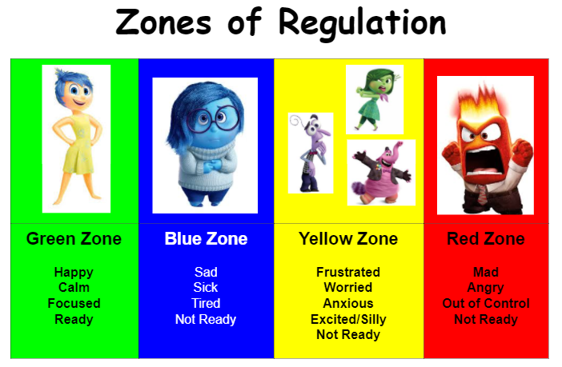

Zones of Regulation Framework
The Child Unit uses the Zones of Regulation Framework to assess and teach self-regulation skills. This framework is a structured, cognitive-behavioral approach that categorizes feelings and states of alertness into four color-coded zones, making emotions easier for children to identify and manage.
The Zones framework provides practical strategies to help children:
- Increase awareness of their emotions and impulses.
- Develop independence in managing sensory needs.
- Improve their ability to handle conflicts constructively.
The Zones of Regulation uses engaging visuals to teach children how to:
- Recognize their feelings and levels of alertness.
- Understand how their behavior affects others.
- Use tools and strategies to manage emotions and maintain self-regulation.

Social Skills Development
Our multidisciplinary team collaborates to teach and reinforce essential social skills through group programming. These sessions target a variety of important life skills, including:
- Zones of Regulation
- Identifying Emotions
- Building a Self-Regulation Toolbox
- Recognizing Triggers
- Practicing "Stop, Opt, and Go" Strategies
- Understanding Behavioral Expectations
- Making Responsible Choices
- Developing Self-Awareness
- Enhancing Problem-Solving Skills
- Cultivating Flexible Thinking
- Improving Social Awareness
- Strengthening Relationship Skills
- Advocating for Oneself
Skill-building is not limited to group sessions; it is reinforced throughout the day within the unit's therapeutic environment. This generalization ensures that children can apply these skills in real-world scenarios.

Sample Daily Schedule
Below is a sample of your child’s daily schedule. Please note that the schedule may vary based on program needs and your child’s individual treatment plan.
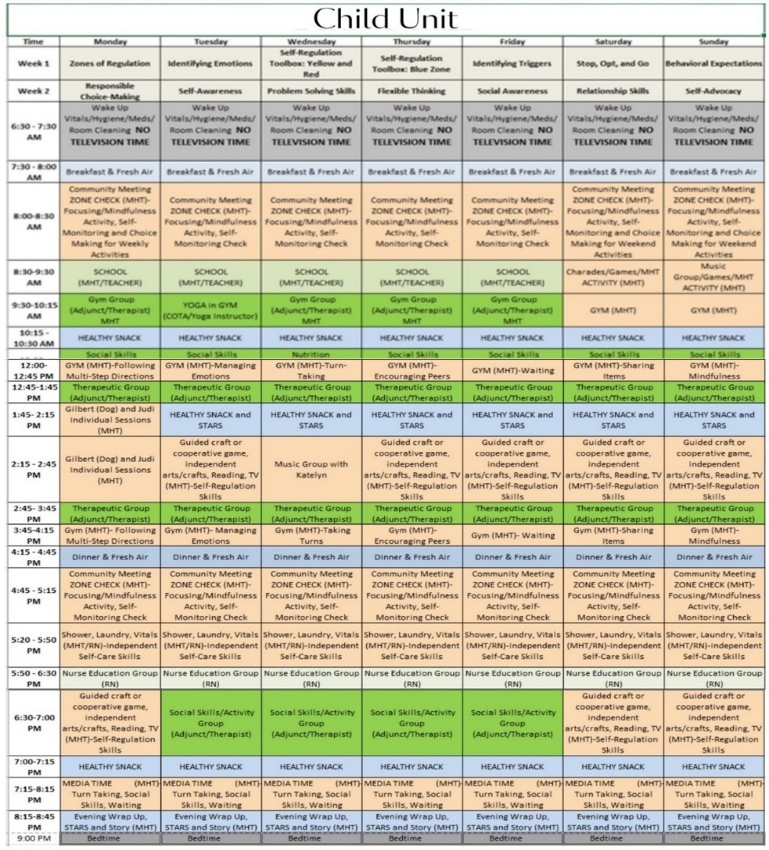
To enhance your child’s experience, we incorporate additional clinical modalities such as meditation and music therapy into their daily routine. These activities promote relaxation, self-expression, and overall well-being while complementing their therapeutic goals.

Family Services and Therapy for Children
Families play a critical role in the therapeutic process, and we are committed to supporting them through family psycho-education and therapy services.
- Within the first 72 hours of admission, your child’s clinician will contact the parent or guardian to arrange a team meeting and schedule ongoing family services.
- Families can participate in weekly family psycho-education sessions and therapy.
- Before discharge, at least one family psycho-education and safety planning meeting will be scheduled to ensure continuity of care and a safe transition.
We aim to empower families with tools, strategies, and support to foster positive growth and stability for their children during and after their stay at WBHH.


Educational Services
Educational services are vital to helping children reintegrate into their external environments. The Child Unit provides developmentally appropriate educational programming led by a qualified educator. Our team also collaborates with your child’s school to ensure a smooth and successful transition after discharge, addressing any specific educational needs.

Discharge Planning
Preparing children to re-enter their lives outside the hospital begins from the day of admission. Our dedicated clinical team works closely with the discharge planner and specialized community providers to meet the needs of both the child and their family.
The clinician and discharge planner will collaborate with parents or guardians to develop a discharge plan that aligns with the child’s therapeutic goals. This plan will be communicated to the child in a way that promotes understanding and supports the ongoing therapeutic process.

Visitation
We value and encourage family involvement and communication throughout the treatment process.

Visitation Times:
Visitors may begin checking in for patient visits 30 minutes before visitation time.
- Tuesdays/Thursdays - Afternoon Visits:
Check-In: 1:30 PM
Visit: 2:00 – 3:00 PM
- Mondays/Wednesdays/Fridays - Evening Visits:
Check-In: 6:00 PM
Visit: 6:30 - 7:30 PM
- Weekends & Holidays:
Check-In: 1:30 PM
Visit: 2:00 – 3:00 PM
If these times are inconvenient, please get in touch with the patient's clinician to make alternative arrangements.

Visitor Guidelines
- All visitors must check in with the receptionist in the main lobby, sign in on the register, and obtain a visitor badge. Visitors must also sign out upon leaving.
- Visitors must be 18 years or older. Children cannot be left unattended in the lobby.
- Personal belongings, such as coats, purses, keys, and bags, are prohibited in the visitation area. Cell phones and cameras are prohibited to protect patient confidentiality.
- Visitors can leave belongings in their cars or secure them in complimentary lockers in the hospital lobby.
- For safety, all visitors will be scanned with an electronic device before entering the visitation area to prevent the exchange of contraband.
- Contraband includes items such as weapons, sharp objects, alcohol, illicit drugs, and medications. A complete list of contraband is available upon request at the reception desk.
- Due to space limitations, only two (2) visitors are allowed per visitation session. If more than two visitors arrive, accommodations will be made to ensure everyone can visit while adhering to this limit.
- Patients' belongings or packages must be left with the receptionist and checked by staff before being given to the patient.
- WBHH maintains a drug- and alcohol-free environment. Visitors appearing under the influence of drugs or alcohol will be asked to leave the property.
- All visitors are expected to respect program rules and the patient’s privacy. Failure to do so may result in being asked to leave.

Food Services
Your child will receive balanced meals and snacks daily, with various options to accommodate their preferences and nutritional needs. A nutritionist oversees the menu planning to ensure nutritious and appealing meals.
If needed, a nutrition consultation can be arranged at your request or the recommendation of your child’s treatment team. Our meal services are equipped to address special dietary needs or medical considerations, and adjustments to the menu will be made accordingly to ensure your child’s health and well-being.


Helpful Caregiver Tips
To ensure your child’s comfort and safety during their stay, please keep the following in mind:
- Clothing:
  - Provide 3 days’ worth of clothing in a disposable brown paper bag.
  - Consider long-sleeved t-shirts; sweatshirts with hoods are prohibited.
  - Ensure your child has slip-on shoes without laces (belts and laces are not allowed).
  - Label your child’s clothing with their name or initials.
- Comfort Items:
  - You may bring one blanket and one stuffed animal to provide comfort for your child.
- Food and Electronics:
  - Outside food is not allowed to protect the health and safety of all patients.
  - Electronics, including cell phones, tablets, outside games, and activities like Legos, are not permitted at WBHH. The only exception is a prescribed communication device required for your child.

Patient Rights
Westborough Behavioral Healthcare Hospital adheres to the Department of Mental Health’s Six Fundamental Patient Rights:
- A humane psychological and physical environment that supports patient well-being.
- The right to receive visitors daily and privately, as is reasonable and safe.
- The right to receive or refuse visits and telephone calls from your attorney, legal advocate, physician, social worker, psychologist, or clergy.
- The right to send and receive unopened, uncensored mail.
- The right to reasonable access to a phone to make and receive confidential calls.
- The right to daily access to outdoor spaces, as is safe and appropriate.

Contact Information
Westborough Behavioral Healthcare Hospital
300 Friberg Parkway, Westborough, MA 01581
For additional questions or support, please contact us:
- Reception Main Line ………………………….……………….……………………508-329-6300
- Child Unit Nurse’s Station.….…………………………………..………………. 508-329-6064
- Clinician…………………………………………………………………………………….508-329-6300

- Nurse Manager………………………………………………………………………….508-329-6055

